1. **Responsive Design with Bootstrap**

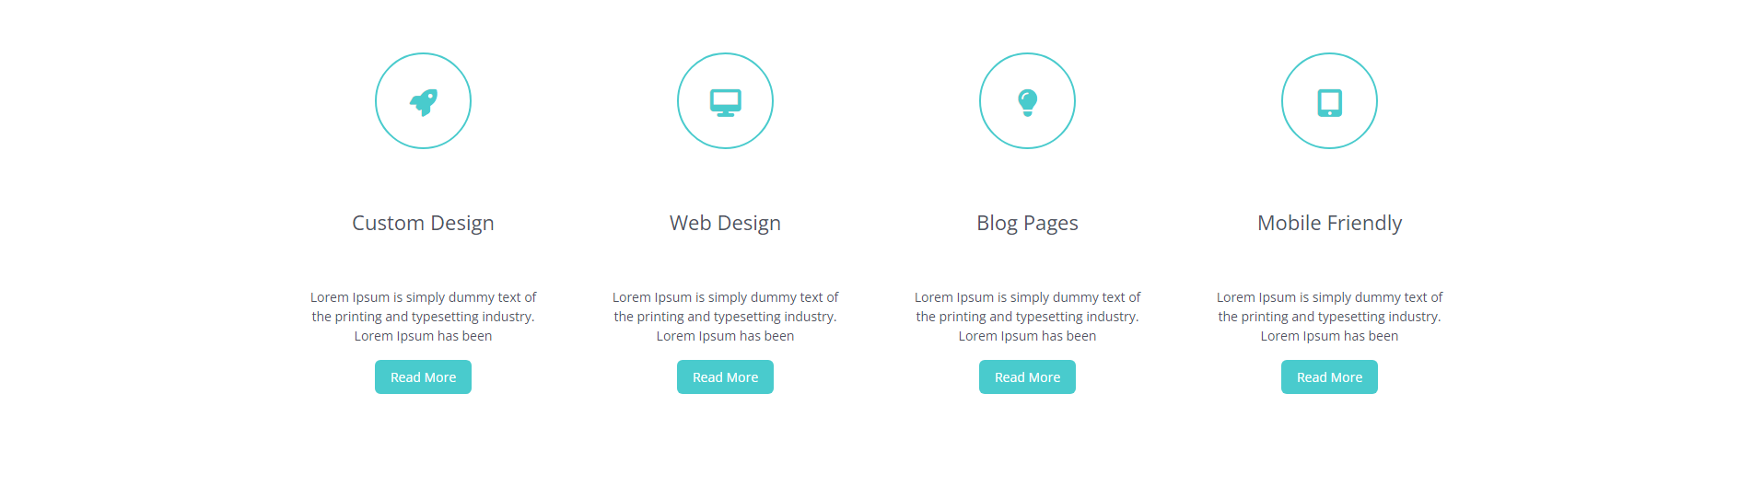

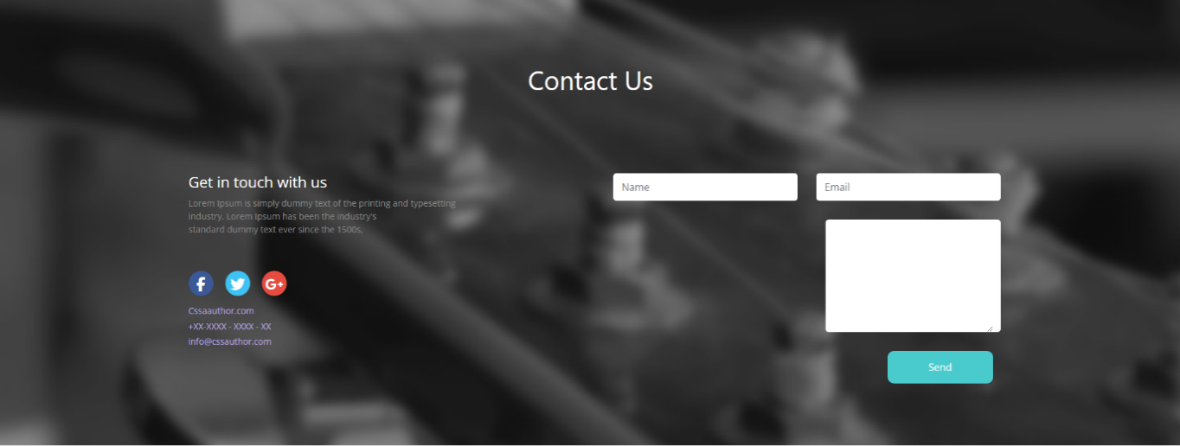

Responsive View on Tablet or Smartphones

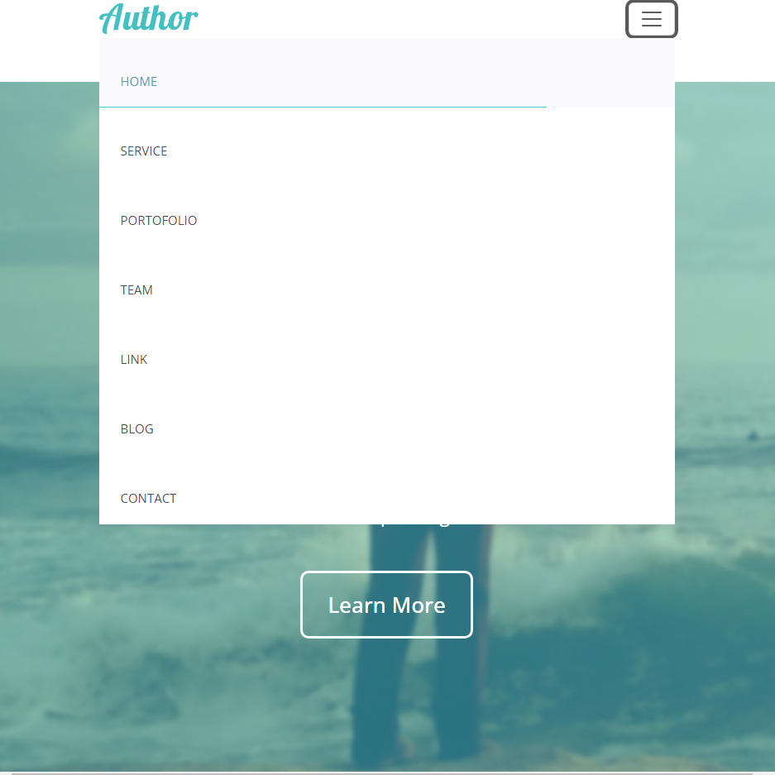



The Elements in the Form Realigns themselves, upon changing the device being used to access the website. A form to submitting name, email and comment (It will be up to the backend developer to handle the post method).

1. **A validation Form**

**On Clicking Sign in Button**

With Validators to check that both Username and Password is provided.

Implemented with JavaScript and jQuery



1. **Responsive Design with Tailwind**



**Navs and Tabs Plugin**

**Only show cards that have the corresponding category.**

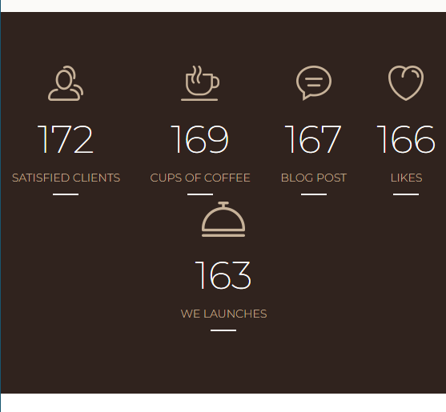

**Counter Up plugin. The number keeps on increasing upon loading the page, until it reaches a predefined maximum value.**

1. **Responsive Design with Raw CSS and HTML**

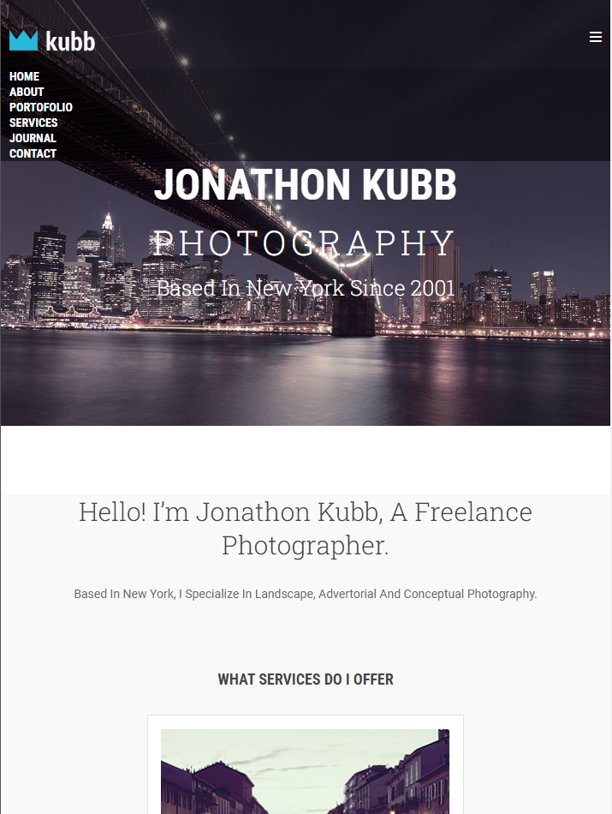**View in smaller designs.**

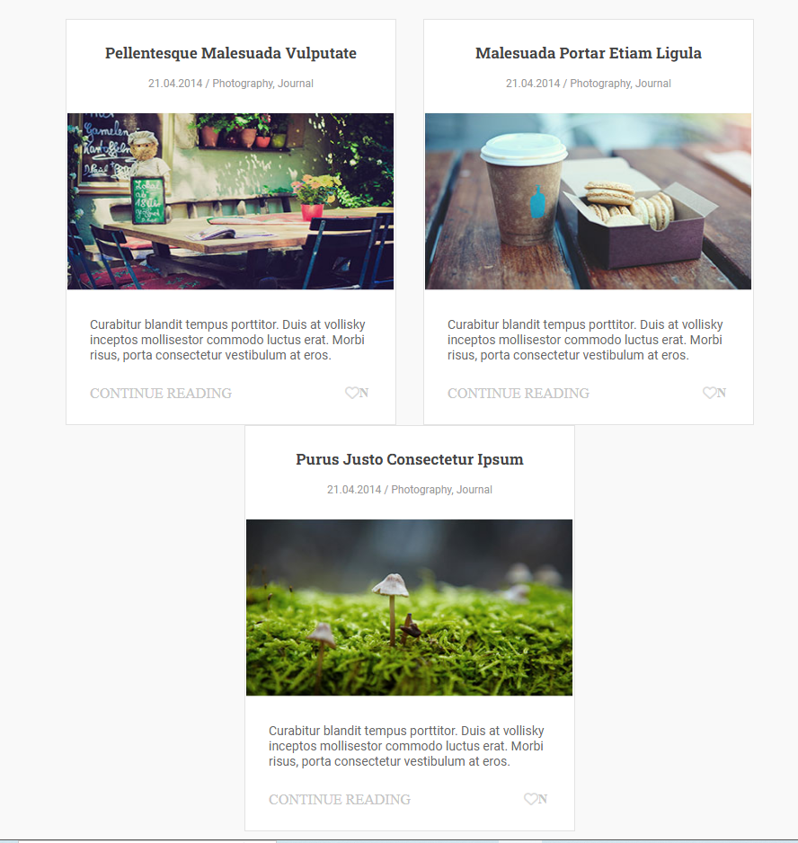**Responsive Card Design. The cards realign up changing dimensions.**

You can find all this and more in my portfolio website, so I hope that you will take the time to check it out.